**Design Explanation for Seasonal Spending Detection Interface**

The Seasonal Spending Detection interface is designed to provide users with a clear and intuitive way to understand and manage their seasonal spending habits. The layout is structured to highlight key information and actions, ensuring users can easily navigate and make informed decisions.

* Navigation and Tabs

At the top of the interface, a navigation bar with tabs (e.g., Overview, Seasonal Trends, Adjustments) allows users to switch between different views. The currently selected tab (e.g., Seasonal Trends) is highlighted in blue to provide clear visual feedback.

* Seasonal Trends Visualization

The central component of the interface is a ​Seasonal Trends Chart, which visually displays historical spending patterns during key seasonal events (e.g., Chinese New Year, Mid-Autumn Festival). The chart uses color-coded bars to represent spending levels, with annotations for significant events. This helps users quickly identify seasonal spikes and trends.

* Budget Adjustments Section

Below the chart, the ​Budget Adjustments section provides AI-driven recommendations for adjusting budgets during high-spending seasons. Each recommendation is displayed in a card format, with a brief description, the suggested adjustment amount, and an action button (e.g., Accept, Customize). The cards alternate between white and light gray backgrounds for improved readability.

* Notifications and Alerts

A ​Notifications Panel on the right side of the interface alerts users when they are approaching a high-spending season. Notifications include details about the upcoming event, the expected spending increase, and a link to adjust budgets. The panel uses a light yellow background to draw attention without being intrusive.

* Manual Adjustment Options

At the bottom of the interface, a ​Manual Adjustment Tool allows users to manually set or modify seasonal spending expectations. The tool includes sliders and input fields for precise adjustments, with a preview of how changes will impact the overall budget.

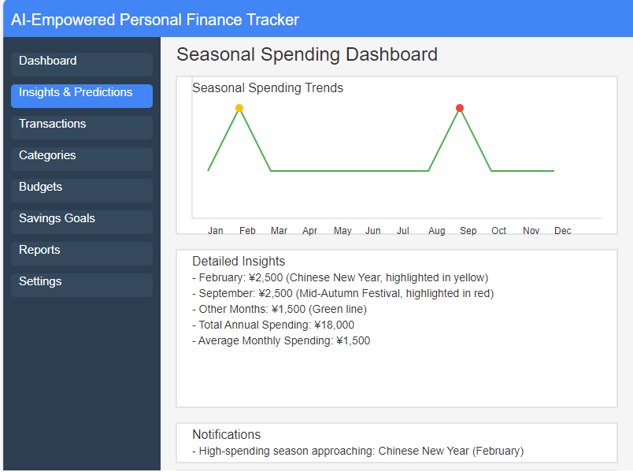

**Design Explanation for Multi-Region Spending Habits Integration Interface**

The Multi-Region Spending Habits Integration interface is designed to help users manage their budgets across different regions with varying spending levels. The layout emphasizes clarity and ease of use, enabling users to switch between regions and view customized budget recommendations.

* Region Selection and Navigation

At the top of the interface, a ​Region Selector allows users to choose their current region (e.g., city, rural area). The selector uses dropdown menus and visual icons (e.g., city skyline, countryside) for intuitive selection. The selected region is highlighted in blue.

* Regional Spending Comparison Chart

The central component is a ​Regional Spending Comparison Chart, which visually compares spending levels across different regions. The chart uses color-coded bars and annotations to highlight key differences (e.g., higher transportation costs in cities, lower living costs in rural areas).

* Customized Budget Recommendations

Below the chart, the ​Customized Budget Recommendations section provides AI-driven adjustments based on the selected region. Each recommendation is displayed in a card format, with a brief description, the suggested adjustment amount, and an action button (e.g., Accept, Customize). The cards alternate between white and light gray backgrounds for improved readability.

* Automatic Region Switching

A toggle switch at the bottom of the interface allows users to enable ​Automatic Region Switching, where the system detects the user's location and adjusts budget recommendations accordingly. The toggle uses green for active and gray for inactive states.

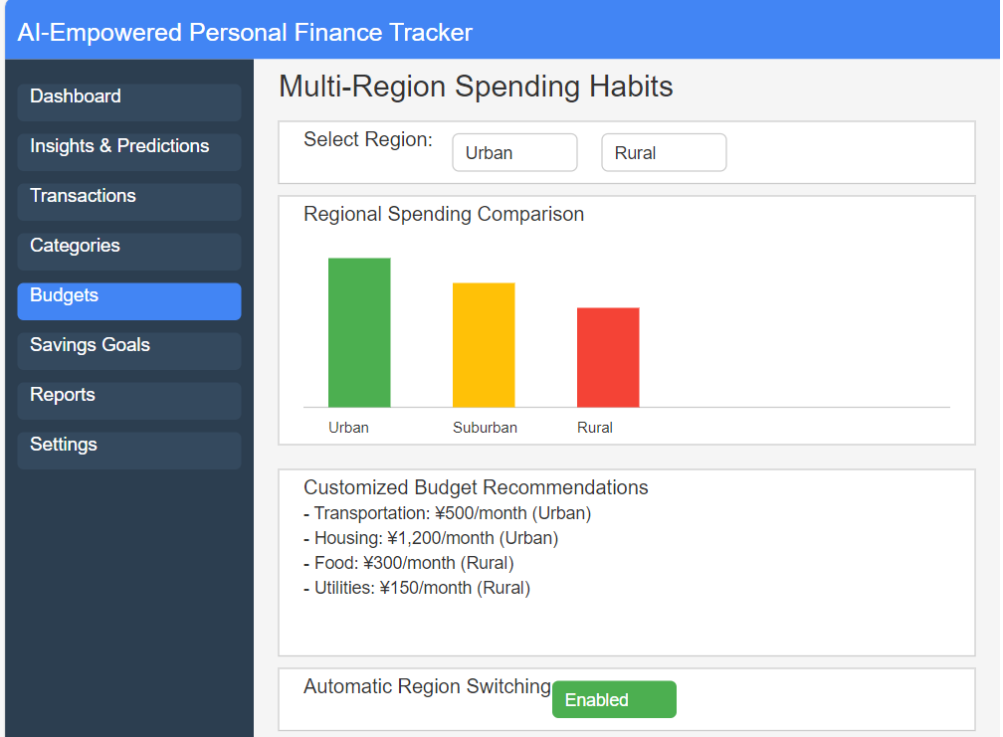

**Design Explanation for Online Shopping Alerts Interface**

The Online Shopping Alerts interface is designed to help users plan their spending during e-commerce promotions (e.g., Double 11). The layout focuses on providing timely notifications and actionable recommendations.

* Promotion Notifications Panel

At the top of the interface, a ​Promotion Notifications Panel alerts users about upcoming e-commerce promotions. Notifications include the promotion name, start date, and a link to adjust budgets. The panel uses a light yellow background to draw attention.

* Budget Adjustment Recommendations

Below the notifications, the ​Budget Adjustment Recommendations section provides AI-driven suggestions for managing spending during promotions. Each recommendation is displayed in a card format, with a brief description, the suggested adjustment amount, and an action button (e.g., Accept, Customize). The cards alternate between white and light gray backgrounds for improved readability.

* Spending Limit Setting

A ​Spending Limit Tool at the bottom of the interface allows users to set limits for specific promotions. The tool includes sliders and input fields for precise adjustments, with a preview of how changes will impact the overall budget.

